# **Final Test Enterprise Application Development 2023A**

**Total marks: 30**

**Time: 12 hours**

**Start: 9am 27th May**

**End: 9pm 27th May**

**Late submission: every 1 hour late submission will result in 15% mark deduction.**

***Note****: Students who have another test or presentation during this time frame will get extra hours. The ratio will be 1 hour test/presentation = 1.5 hour extra.*

*Please submit the evidence along with your submission in the comment section of Canvas submission. Evidence includes email, announcement, or equivalent to document that you spent time for other assessment.*

**Rules:**

1. Students can use Canvas and Internet for reference and other AI generator tools such as Copilot and ChatGPT. No discussion or exchange of ideas, external support is allowed.
2. **Students put all the answer files into a folder, zip it and submit the zipped file. Students also download this online document as a docx file and suffix the file with their name. Students provide the link (or screenshots) of their work in this file and submit together with the source code zip file.**
3. Sharing or disclosing lab test questions to forums, Q&A platforms are prohibited.
4. Students should make their own assumptions based on common sense. Please don’t ask questions that are common sense and straightforward as it can slow down your progress.

**Question 1 (15 marks). (Frontend) Build a web application that displays overviews of countries around the world.**

* The country API can be accessed here for free without API key needed:

<https://restcountries.com/v3.1/all>

* Students can use any frontend frameworks including pure CSS, Bootstrap, AngularJS, ReactJS etc.
* Students are free to come up with their own design but the app should follow the common web design: UI, UX, responsive.
* Expected features:

1. **(10 marks) Landing page**

* The web should display a list of all countries with basic info (up to 10 attributes). Must show flags
* A search should allow by country name
* A filter by region and subregion (should be combine with search)
* A filter by population range: 0-5, 5-10, 10-50, 50-100, >100 millions
* A sort by population and countries name
* A pagination bar

1. **(5 marks) Detailed page**

* The detailed page should display all information about the selected country.
* There are links to show similar countries based on equivalent population, same regions, shared border, same language etc. This is similar like you visit a shopping website and they often suggest similar products or books.

***Students pastes all the screenshots of their answers below:***

…………………………………………………………………………………………………………

…………………………………………………………………………………………………………

………………………………………………………………………………………………………

**Question 2 (15 marks). (Fullstack) Build a fullstack enterprise application for production management.**

A company needs a software system to manage their manufacturing so you get contracted to build the app for them. The app must use Spring framework for the backend and for the frontend it is open.

Production management system is a complex field with lots of new terms, processes, and workflows. In this contract, you build a simple system with a simple workflow.

The first important form you must develop is to manage the product list. A product will have an id, name, unit, images, and price, and a category which can be a finished product or components or raw materials.

A product will need many components in order to be built as a complete product. This structure is called the Bill of Materials.

When a manufacturing order is made, the system will check inventory of components or materials to see if they are available. If not, a purchase order will be made. If all the components and materials are ready, users will confirm the manufacturing order. The status of manufacturing order is changed to Confirmed

Then workers start to produce. The status of manufacturing order is changed to In-progress. During the production process, users and workers can take logs with text and pictures to let other people know about the progress. Once it is done, workers mark the status of manufacturing order as Done.

More information about Products and Bill of materials setups:

<https://www.youtube.com/watch?v=PjZJVKT_AF4&t=442s>

Manufacturing order:

<https://www.youtube.com/watch?v=PjZJVKT_AF4&t=780s>

**Students to build the following features:**

1. **(5 marks) Product Management**

* Product management including add, update, delete, list view all the products. Filter product by category, search product by name.
* Product list can be shown by table view or icon view:

Add product:

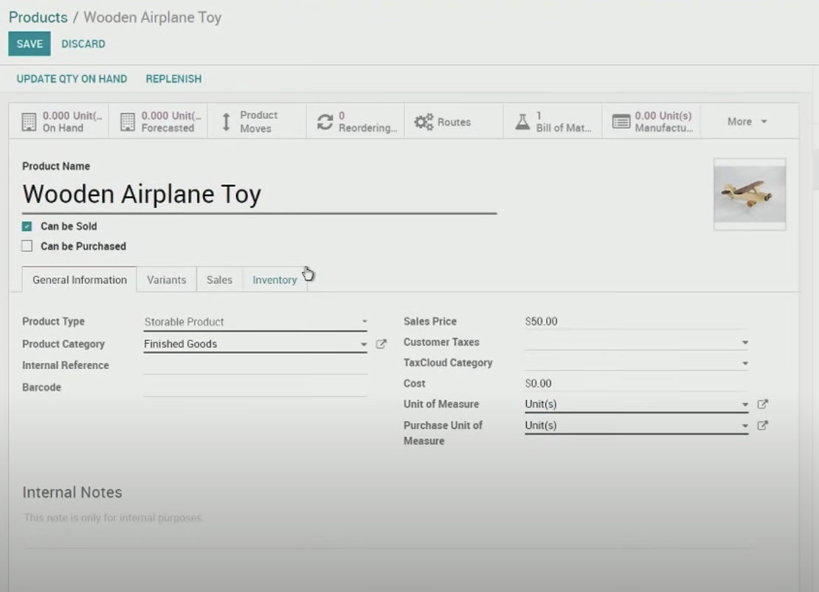

Icon view:

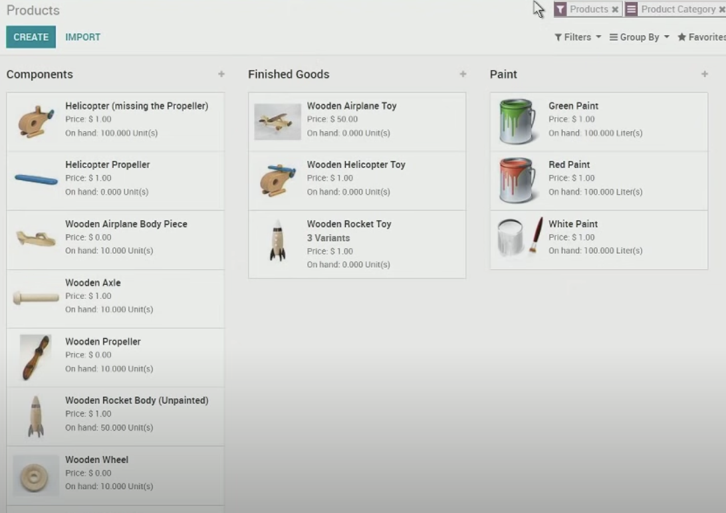

Table view:

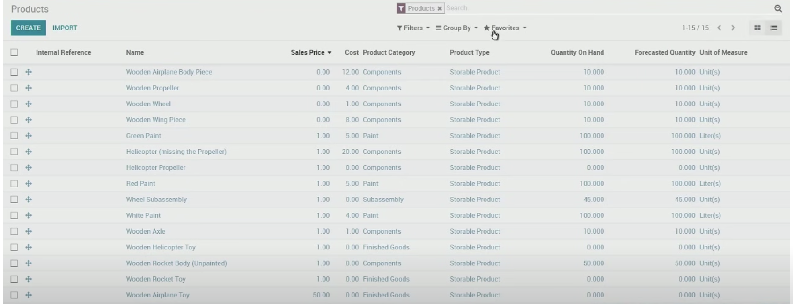

***Students pastes all the screenshots of their answers below:***

…………………………………………………………………………………………………………

…………………………………………………………………………………………………………

………………………………………………………………………………………………………

1. **(5 marks) Bill of Materials**

One product will have one bill of materials. Form to define a bill of materials is as follows:

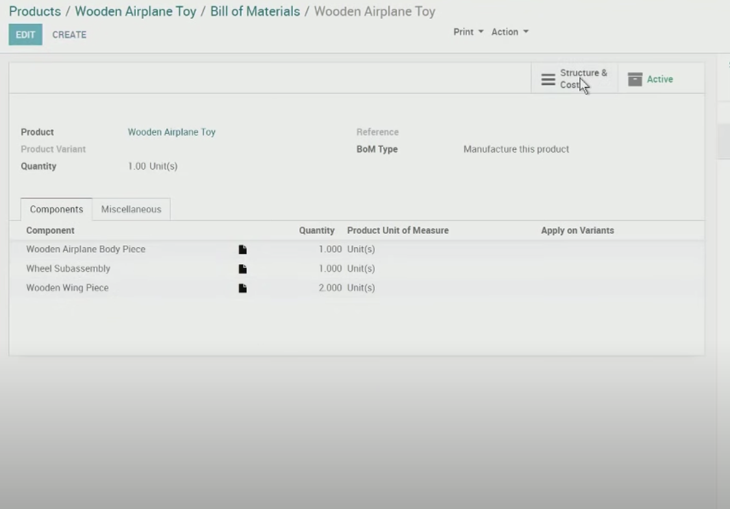

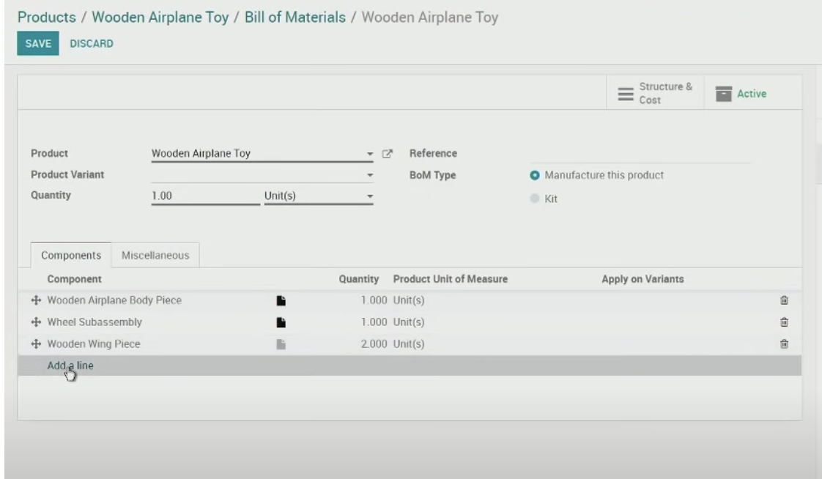

***Students pastes all the screenshots of their answers below:***

…………………………………………………………………………………………………………

…………………………………………………………………………………………………………

………………………………………………………………………………………………………

1. **(3 marks) Manufacturing order:**

Add a manufacturing order:

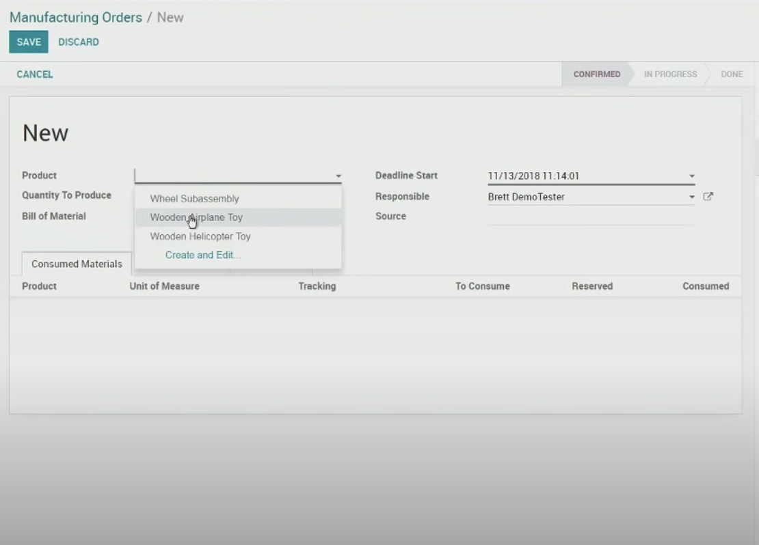

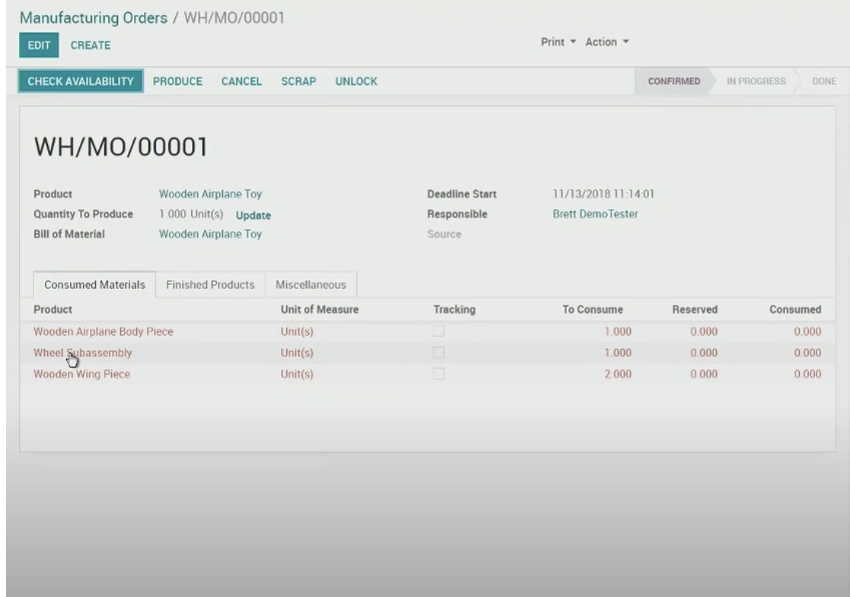

***Students pastes all the screenshots of their answers below:***

…………………………………………………………………………………………………………

…………………………………………………………………………………………………………

………………………………………………………………………………………………………

1. **(2 marks) Logs message about the status:**

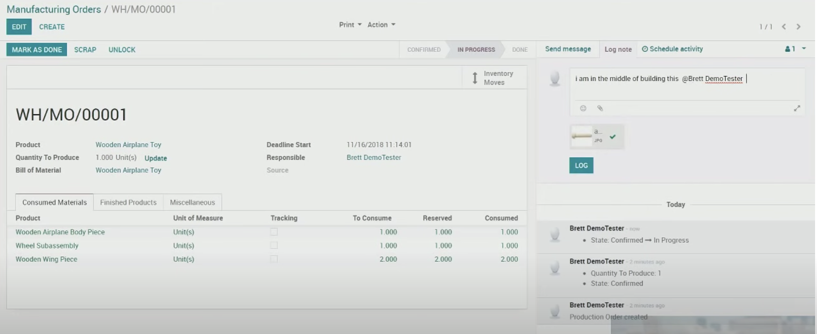

***Students pastes all the screenshots of their answers below:***

***Good luck to everyone!!!!!***

**End of the test**